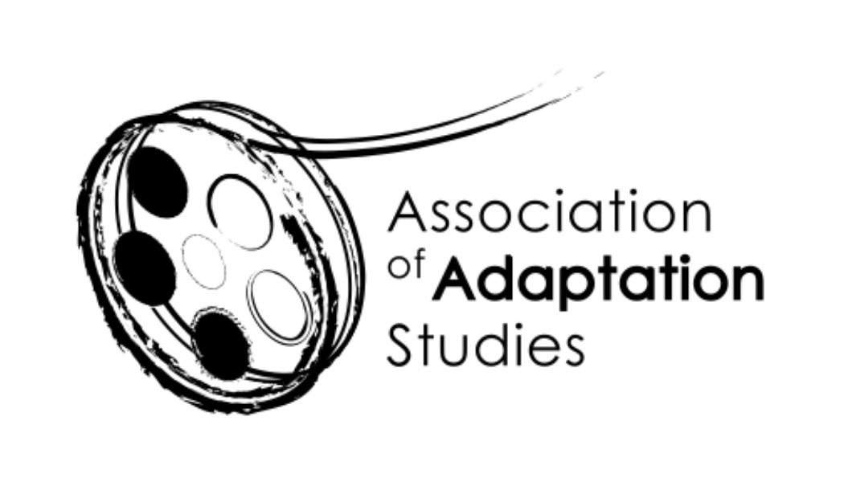

**Association of Adaptation Studies**

Registered Charity

1133677

AGM

*Meeting in association with the AAS Conference*

*hosted by the University of Lisbon*

**24/06/2022**

1. To approve the minutes of the 2021 AGM (Kyle Meikle, Secretary)

Thirty-two members in attendance in person, four virtually. Trustees in attendance included Kyle, Kamilla, Eckart, Monika, Jeremy, and Tom, and (remotely) Julie and Deborah, and (in-waiting) Alan Redmon. The minutes were approved.

1. Chairs’ report

AAS in 2021-22 (Kamilla Elliott and Julie Grossman)

Membership (Jim Fleury)

The chairs highlighted how technology had connected adaptations scholars more frequently over the past years—whether the hybrid conference this year, the virtual AAS conference based in Edinburgh, the first joint LFA and AAS conference, the “Remixing the Classics” and “Locating the Child” roundtables, or the affiliated “To Be Continued” serialities symposium and the Vellore Institute of Technologies’s event, all virtusal. These events, though sometimes challenging to stage, have helped us circumvent funding issues for prospective attendees.

Julie updated our membership numbers: 122, up from 91 the year, and then up to 160 the week of the conference. We had a close to 100% join rate for the organization; Julie encouraged everyone else to join the organization. We’ve had a 20/20% increase in membership/enrolment. Kamilla said that these rates are encouraging, especially with the lower costs to make us more accessible. She touted the membership benefits (newsletter, discounts, etc.) and asked for other ideas. Silvia speculated if the 20% increase was due to hybrid and online models, with a lot of people presenting in one day, and noting the diversity of scholarship coming from (for instance) Brazil. Kamilla reflected on hybrid, wondering if in future years we could have parallel online/in-person panels or panels where half the members are virtual and half are in-person, to more fully integrate online participants. Kamilla asked for other suggestions, with one member recommending that we create an events-only, public facing mailing list (with Madeleine suggesting that we use that to leverage membership for admission to events themselves).

1. Treasurer’s report (Anna Blackwell)

See Anna’s report.

Kamilla noted that if we’re going to sustain post-graduate and ECR bursaries, we need to generate more income, otherwise we’re likely to decrease bursaries or raise fees slightly. Thanks were given to Anna for her patience in her role as treasurer!

Colleen suggests AAS-themed merchandise (something Eckart had half-joked about before).

We revisited the idea of a graphic/logo revamp/design competition, with Kamilla planning to sidebar with Deborah.

1. Results of the AAS Trustee election (Kyle Meikle)

The newly elected trustees were reported:

* Anna Blackwell
* Colleen Kennedy-Karpat
* Thomas Leitch
* Kyle Meikle
* Monika Pietrzak-Franger
* Allen Redmon
* Eckart Voigts
* John Williams
* Christina Wilkins

1. Welcome to incoming AAS Trustees (Kamilla Elliott and Julie Grossman)

Kamilla extolled the virtues of a new class and noted that she and Julie will stay on for a transition period (and may even return as trustees further on). Julie thanked the board, trustees, and membership.

1. Thanks to outgoing AAS Trustees and to Jim Fleury (Eckart Voigts)

Thanks were given to outgoing trustees, including Joyce and Jeremy. Eckart thanked outgoing website manager Jim Fleury for handling the AAS site and newsletters. He encouraged folks to sign up for the YouTube channel and showed us some of its newest addtions.

1. Congratulations to student and early career winners of AAS travel bursaries (Jeremy Strong)

We congratulated the student and early career AAS bursary winners, including Maria Chiara Ottalina, Deborah Natanishi, and Steven Roberts. A reminder that we were able to support these bursaries because of membership dues! One winner was denied a visa to attend the conference.

1. Report on graduate pre-conference workshop AAS Lisbon 2022 (Monika Pietrzak-Franger)

Monika reported on the pre-conference workshop for postgrad students, where they described their projects to solicit feedback. The workshop included a range of topics and methodologies, as well as a geography (with participants coming from Canada, Poland, Great Britain, and India). Colleen asked if this could be turned into an ongoing workgroup instead of a one-off event.

1. Links between AAS, LFA, MLA, NEMLA, SAMLA (Julie Grossman and Tom Leitch)

Tom reported on crossover events, including SAMLA’s series of sponsored panels (ongoing for 11 years), the joint LFA/AAS conference, the serialities symposium, the panels at NEMLA, and MLA. Colleen asked about hybrid options. Members suggested we forge links with Comparative Drama, the Screenwriting Research Network, the Shakespeare Association conference. Madeleine suggested we look to orgs outside of Anglo-centric borders. John Williams again raised the idea of the Japanese conference. The Vellore Institute also remains a possible site for collaboration.

1. Future AAS conferences (Kamilla Elliott)

University of Birmingham 7-9 June 2023

Request for future conference venues and online conferences

With thanks to Christina Wilkins, a new trustee who will host next year’s conference. Silivia asks about a possible conference in South America.

1. Any other business

Jeremy advertised fully funded PhD buraseries for UK students at the University of West London. I advertised for submissions to *Adaptation*. We all thanks Ana and Jose, our conference organizers.

1. Date of Next Meeting: 9 June 2023, University of Birmingham