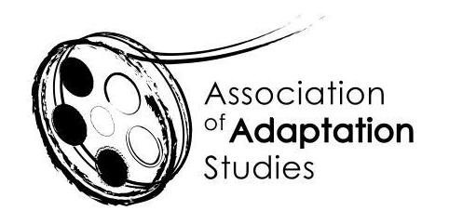

ADAPTATION STUDIES PGR/ECR MENTORING WORKSHOP
University of Szczecin, Poland, 4 June 2024

*** APPLICATION ***
The Association of Adaptation Studies invites PhD students working on any aspect of adaptation to participate in the mentoring workshop immediately preceding the 19th Annual Conference. It will take place on the afternoon of Tuesday, 4 June 2024 at the conference venue. Chaired by Trustees of the Association of Adaptation Studies, Prof. Thomas Leitch and Dr Christina Wilkins, this workshop will focus exclusively on your individual projects. If you search for expert and peer feedback, this is the place to be!
The mentoring workshop is an initiative of the Association of Adaptation Studies designed to support emerging scholars in this expanding field. It will consist of short (15-minute) presentations of some aspect of your research project (foundational questions, progress to date, problems encountered, etc.), each followed by a longer discussion session. If you are selected for the workshop, you will be asked to submit the outline of your project/chapter/theoretical framework (up to 3 pages) so that it can be circulated among the participants beforehand. In order to ensure a focus on healthy and constructive criticism, no external participants will be admitted, and the group will make every effort to support the presenters. All workshop materials presented will remain confidential.

Because our time is limited, only 5-7 presentations can be accepted. The conference organisers will provide lunch on the day of the workshop, and AAS will contribute 50 euros towards the extra night’s accommodation and cover all workshop fees.

In order to apply, please fill out the application and submit it to Thomas Leitch (tleitch@udel.edu) no later than 9 March 2024. The selection of participants will be announced by 22 March 2024.

If you are selected for the workshop, send your discussion materials (up to 3 pages) by 15 May 2024 to Thomas Leitch (tleitch@udel.edu). These materials will be circulated among the participants. All participants are requested to read all contributions to the forum in advance so that they can meaningfully contribute to the discussion and offer peer/expert feedback.

Should you be selected, you will need to begin or renew your membership in the AAS to confirm your place at the workshop by 5 April 2024 to allow time for your place to be reallocated should you choose not to attend. To join AAS, please follow this link: http://www.adaptation.uk.com/join-the-association/ To propose a paper and/or register for the conference, visit the Association of Adaptation Studies website http://www.adaptation.uk.com.

Name
Email
Institution
Starting date of the PhD Project
Project Title
Project Abstract
(250 words)

