Registered Charity
1133677
Treasurer’s Report
2021-22

AAS account at
June 16 2022: c.f. £11,122.18
- £3,861.50 in PayPal account
- £7260.68 in current account as of 27 May 2022

June 03 2021: c. £17,358.21

Outgoings include:
- Support of 2021 conference - £792.00 (09 July 2021)
- Repayment of erroneously received OUP royalties to Deborah Cartmell and Imelda Whelehan - £4499.00 (17 August 2021) and £4318.00 (08 September 2021)
- Website support/hosting - £144.00 (20 April 2022), £35.99 (15 October 2021)
- MailChimp subscription – $133.84 (approx. £110.23)
  - Please note a monthly price increase from Feb 2022 from $10.79 to $11.88
= £9,899.22

Incomings:
- Membership fees: £3,905.00

Items to note:
- Post-conference outgoings include:
  - ECR bursaries £1000
  - Postgraduate bursaries £1250
  - Mentoring workshop support funds £250
  - Membership secretary TBC.
- Treasurer currently working with Virgin Money to set up internet banking for account so that we can be less reliant on PayPal transfers in future. The treasurer acknowledges the difficulty with PayPal for some international members and India in particular.
- Membership sales are up 28% on last year (see below from PayPal report)
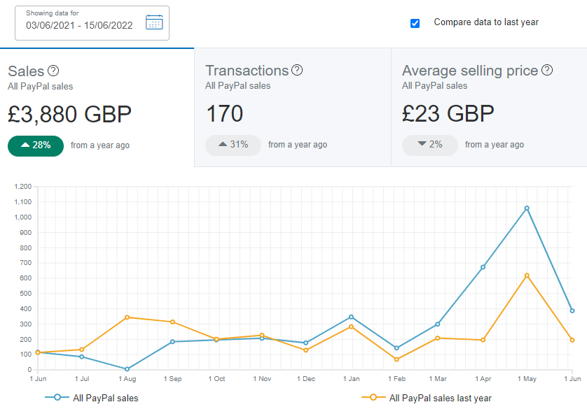

Further context:
The PayPal report provides a further breakdown of the nationality of members/subscribers. For the period above, 18% of members were domestic (UK) versus 82% international. This represents a significant change from 2020-21 when 30% of members were domestic and 70% international. There are particular increases in the number of members in Brazil (from 3 to 14), USA (from 24 to 40), Japan (1 to 4), Poland (2 to 8).

Anna Blackwell
Treasurer, Association of Adaptation Studies
June 2022

