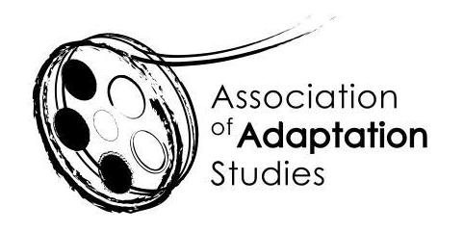

POSTGRADUATE TRAVEL BURSARY APPLICATION

The Association of Adaptation Studies 17th Annual Conference

University of Lisbon, Lisbon, Portugal, 23-24 June 2022

Up to three travel bursaries are available for postgraduate students delivering research papers at the 2022 conference: up to two for students based in the UK or EU (£250 each) and one for students based outside of the EU (£500 each). We expect you to be proactive in applying for funding from your home institution, and other appropriate sources. Bursary applicants must be registered members of the AAS. To register please follow this link: http://www.adaptation.uk.com/join-the-association/

Applications should be sent to Professor Jeremy Strong (jeremy.strong@uwl.ac.uk)
Applications must be submitted no later than 15th February 2022.

Name
Email
Institution
Year of Study (MA/PhD)
Paper Title
Paper Abstract
(150 words)

Amount of funding provided by your institution
Amount applied for from other funding sources (list)
Please state why the travel bursary would be helpful to you (maximum 150-words)

