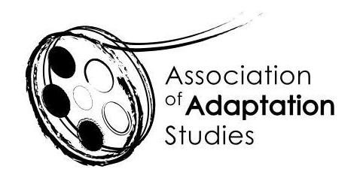

EARLY CAREER RESEARCHER BURSARY APPLICATION

The Association of Adaptation Studies 17th Annual Conference

University of Lisbon, Lisbon, Portugal, 23-24 June 2022

Two travel bursaries are available for early career researchers (ECRs) delivering research papers at the 2022 conference: one for ECRs based in the UK or EU (£250) and one for ECRs based outside of the UK or EU (£500). We expect you to be proactive in applying for funding from your home institution, and other appropriate sources. Bursary applicants must be registered members of the AAS. To register please follow this link: http://www.adaptation.uk.com/join-the-association/

These bursaries are intended to support ECRs who are at an early stage in their academic careers and whose income might preclude their participation in our conferences. Typically, though not always, this will mean individuals who have completed their PhDs within the last three years. Hence, in the UK, ECRs on the ‘lecturer’ salary scale (but not ‘senior lecturer’ or higher) would be considered eligible, as would individuals undertaking hourly-paid teaching. For applicants from the EU and worldwide a broadly equivalent eligibility criterion will apply. Successful applicants will need to provide evidence of their ECR status.

Applications should be sent to Professor Jeremy Strong (jeremy.strong@uwl.ac.uk)
Applications must be submitted no later than 15th February 2022.

Name
Email
Institution
Institutional role and level
(e.g. ‘lecturer’, ‘hourly-paid tutor’.)
Paper Title
Paper Abstract
(150 words)

Amount of funding provided by your institution
Amount applied for from other funding sources (list)
Please state why the travel bursary would be helpful to you (maximum 150-words)

