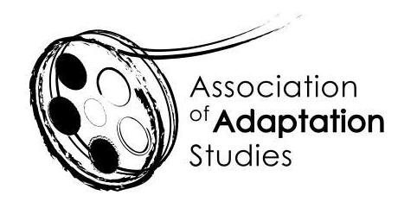

ADAPTATION STUDIES MENTORING WORKSHOP
University of Lisbon, Portugal | 22 June 2021

*** APPLICATION ***
The Association of Adaptation Studies invites PhD students working on any aspect of adaptation to participate in the mentoring workshop immediately preceding the Annual Conference. It will take place on 22 June 2022 at the conference venue (we are planning for on-site participation). Chaired by Trustees of the Association of Adaptation Studies, Prof. Monika Pietrzak-Franger and Prof. Thomas Leitch, this workshop will focus exclusively on your individual projects. If you search for expert and peer feedback, this is the place to be!

The mentoring workshop is a new initiative of the Association of Adaptation Studies designed to support emerging scholars in this expanding field. It will start at 1pm and will consist of short (15-minute) presentations of some aspect of your research project (foundational questions, progress to date, problems encountered, etc.), each followed by a 30-minute discussion session. If you are selected for the workshop, you will be asked to submit the outline of your project/chapter/theoretical framework (up to 3 pages) so that it can be circulated among the participants beforehand. In order to ensure a focus on healthy and constructive criticism, no external participants will be admitted, and the group will make every effort to support the presenters. All workshop materials presented will remain confidential.

Because our time is limited, only 5-7 presentations will be possible. The AAS will contribute £50 towards the extra night’s accommodation and cover all workshop fees.

In order to apply, please:

Fill out the application and submit it to Prof. Thomas Leitch (tleitch@udel.edu) no later than 15 January 2022. The selection of participants will be announced by 15 February 2022.
If you are selected for the workshop, send your discussion materials (up to 3 pages) by 1 May 2021 to Prof. Monika Pietrzak-Franger (monika.pietrzak-franger@univie.ac.at). These materials will be circulated among the participants. ALL participants are requested to read ALL contributions to the forum in advance so that they can meaningfully contribute to the discussion and offer peer/expert feedback.

Please be aware that, should you be selected, you will have to be a member of the Association to confirm your place at the workshop. You will need to do this in advance of the conference to allow time for your place to be reallocated should you choose not to attend. To join AAS, please follow this link: http://www.adaptation.uk.com/join-the-association/. To propose a paper and/or register for the conference, visit the Association of Adaptation Studies website http://www.adaptation.uk.com.

Name
Email
Institution
Starting date of the PhD Project
Project Title
Project Abstract
(250 words)
Mobility (will you be able to attend the event in person? – please consider current regulations)

