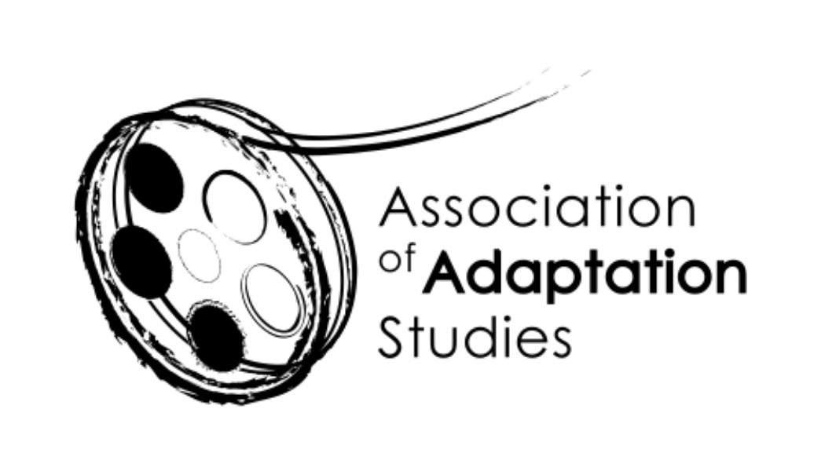
Association of Adaptation Studies
Registered Charity
1133677

AGM

Online via Zoom

1/10/2020

Trustees in attendance: Julie Grossman (Co-chair), Kamilla Elliott (Co-chair), Jeremy Strong, Thomas Leitch, Deborah Cartmell, Eckart Voigts, Anna Blackwell (Treasurer), Kyle Meikle (Secretary), Joyce Goggin

Regrets: Monika Pietrzak-Franger

- To approve the minutes of the 2019 AGM (Kyle Meikle, AAS Secretary)

We discussed matters arising from last year’s minutes.

Kamilla asked whether members wanted to establish an early career bursary for upcoming conferences.

Kamilla asked Bethany Wood to speak about connections between AAS and the Association for Theatre in Higher Education (ATHE). Bethany said that she had sent out AAS calls for papers to focus groups within ATHE and saw at least one ATHE name on the AAS programme for Dijon. Bethany mentioned that she could also send papers through LMDA (the Literary Managers and Dramaturgs of America), and that she and Jane Barnette (author of Adapturgy: The Dramaturg's Art and Theatrical Adaptation) were looking at putting a panel together for Edinburgh.

Kamilla urged all members to circulate CFPs to other organizations to which we belong.

Candice Lemaire reminded members that articles for a special issue of Interfaces drawing from abstracts for the cancelled Dijon conference were due 30 October. Kamilla suggested that Candice and Shannon Wells-Lassagne promote the issue in a brief video after its publication.

Kamilla discussed the possibility of a special issue of Adaptation devoted to diversifying and/or decolonizing adaptation studies. Deborah supported the idea but noted that there’s currently a two-year slate of issues to come. Kyle suggested a “virtual issue” in the meantime, which Oxford has put together in the past—making several previously published articles on a given subject (e.g. Jane Austen) free to view for a limited period, joined together by a prefatory intro. Deborah noted that the task would really be to find someone to write the intro to the virtual issue. (ACTION ITEM: Kyle or Deborah contact OUP about possibility of a virtual issue and solicit someone to write the intro.)

Lastly, Kamilla noted that our efforts to diversify have included moving away from strictly white male keynotes.

The minutes were approved with 12 yeses and 1 abstention.

- Chairs’ report

Membership report (Julie Grossman)

Julie reported that we currently have 91 members, versus 123 at about this time last year. Julie anticipates that membership will rise by 20-30 after acceptances go out for the Edinburgh conference.

Julie thanked Jim Fleury for updating the membership list and contacting lapsed members.

She asked if anyone had questions about membership or about our current newsletter delivery system, MailChimp, which we recently upgraded to be able to include links, attachments, etc.

Membership resources (Kamilla Elliott)

Kamilla reported efforts outside of conferences to provide benefits to members, including the twice-yearly (at least) newsletter), student bursaries, early career bursaries, and PhD mentorship sessions attached to conferences. Kamilla mentioned that Deborah has talked about adding a second conference in addition to our yearly meeting—evenly spaced out from that annual gathering. Deborah said that Judith Buchanan has suggested possibly holding a conference at St. Peter’s College (University of Oxford).

Jeremy raised the idea of staggering or reducing membership dues for scholars from underdeveloped countries; Deborah suggested revising membership dues to consider income levels instead. Julie and Kamilla held a vote to see if there was interest in the Trustees taking this idea under consideration; the motion passed with 12 yeses. Anna and Bethany suggested that we should also consider take non-tenure track/contingent/precarious scholars into account (possibly creating a separate category for them). Kamilla nominated Julie, Jeremy, and Anna to think through this tiering. (ACTION ITEM: Follow up on tiered membership with Trustees.)

- Treasurer’s report (Anna Blackwell)

Anna reported that we have a healthy amount of savings, estimated at around £12,000, with relatively minimal outgoing costs (primarily payments to Jim Fleury and Maple Wyand for maintenance of the membership list/website and YouTube channel, respectively).

The members discussed the advantages and disadvantages of being listed as a charity association. Kamilla suggested following up on this question with Trustees.

- Developing online resources (Kamilla Elliott and Eckart Voigts)
Kamilla talked about the new, not-yet-entirely-public AAS YouTube channel, managed primarily by Eckart, Kyle, and Maple. The channel currently includes a video by Eckart (and Charles Dickens), and intros from Julie, Jeremy, and Kamilla (who granted permission for their videos to be made public). The channel also includes a playlist of adaptation studies-related videos curated mostly by Maple. Kamilla and Kyle mentioned that book launches and roundtable excerpts will be featured on the channel down the line. Kamilla asked members to send inquiries of interest about contributing content to Eckart. She thanked Jim Fleury for his Herculean efforts to update the website.

- Links between AAS and LFA (Julie Grossman and Tom Leitch)

Tom explained that AAS and LFA had planned to meet jointly as early as next year—and that LFA president Allen Redmon is in favour of such a meeting—but that the plans have obviously been delayed due to COVID-19. There are nevertheless AAS and LFA folks who have become active in the other organization.

More successful have been the AAS’s attempts, spearheaded by Tom, Julie, and Doug Lanier, to join AAS up with the Modern Language Association (MLA) and its regional conferences. Following the long history of AAS-sponsored panels at the South Atlantic Modern Language Association’s annual meeting, AAS sponsored a number of panels (nine to be exact) at the Northeast Modern Language Association (NEMLA) meeting this past spring. SAMLA and NEMLA will both be virtual this academic year, but both will still feature a number of adaptation panels; the deadline for NEMLA submissions was just extended to 11 October.

The MLA meeting in January, meanwhile, will include three AAS events.

- Next AAS conference (Kamilla Elliott)
June 10-11, 2021 Queen Mary’s University, Edinburgh (Robert Munro and Michael Stewart)
Kamilla suggested that the organizers for next year’s conference be prepared to go virtual, but nothing has been decided yet. We have other conferences in the works but nothing definite as yet.

- AAS and Diversity (Joyce Goggin)

Kamilla mentioned our increasingly diverse keynotes speakers, as well as the diversity of nations from which we received submissions for what would have been the Dijon conference.

Joyce has recruited Christine Geraghty to do a brief video on colorblind casting, and has reached out to Karen King, a producer as Productions Without Borders in Canada. Kyle suggested reaching out to Kristen Warner, who’s written on colorblind casting and published a review of Widows in Adaptation. Deborah mentioned Dr Farah Karim-Cooper, head of higher education and research at the Globe, as another possible voice to amplify. Kamilla asked members to send all suggestions to Joyce (j.goggin@uva.nl).

Maria Marcsek-Fuchs encouraged similarly “low-threshold” events like the AGM to spur membership; Kamilla wondered if we should have a digital membership.

- Any other business

Julie promoted the forthcoming book launch for Kamilla’s Theorizing Adaptation.

Julie suggested tabling the discussion of expanding the number of trustees (possibly to ten?) until next year.

Deborah suggested a launch for Tom’s The History of American Literature on Film.

- Date of Next AGM: June 11 2021, we hope at Queen Mary’s University, Edinburgh

