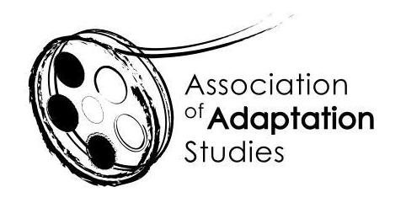

ADAPTATION STUDIES MENTORING WORKSHOP
University of Burgundy, Dijon, France | September 30, 2020

*** APPLICATION ***
The Association of Adaptation Studies invites PhD students working on any aspect of adaptation to participate in the first mentoring workshop immediately preceding the 15th Annual Conference. It will take place on September 30, 2020 at the conference venue. Chaired by Trustees of the Association of Adaptation Studies, Prof. Thomas Leitch and Prof. Monika Pietrzak-Franger, this workshop will focus exclusively on your individual projects. If you search for expert and peer feedback, this is the place to be!

The mentoring workshop is a new initiative of the Association of Adaptation Studies designed to support emerging scholars in this expanding field. It will start at 1pm and will consist of short (15 min) presentations of some aspect of your research project (foundational questions, progress to date, problems encountered, etc.), each followed by a 30-min discussion session. If you are selected for the workshop, you will be asked to submit the outline of your project/chapter/theoretical framework (up to 3 pages) so that it can be circulated among the participants beforehand. In order to ensure a focus on healthy and constructive criticism, no external participants will be admitted, and the group will make every effort to support the presenters. All workshop materials presented will remain confidential.

Because our time is limited, only 5-7 presentations will be possible. The conference organisers will provide lunch on the day of the workshop and AAS will contribute 50 euros towards the extra night’s accommodation and cover all workshop fees.

In order to apply, please:

Fill out the application and submit it to Prof. Monika Pietrzak-Franger (monika.pietrzak-franger@univie.ac.at) no later than May 1, 2020. The selection of participants will be announced by May 15th, 2020.
If you are selected for the workshop, send your discussion materials (up to 3 pages) by August 15, 2020 to Thomas Leitch (tleitch@udel.edu). These materials will be circulated among the participants. ALL participants are requested to read ALL contributions to the forum in advance so that they can meaningfully contribute to the discussion and offer peer/expert feedback.

Please be aware that, should you be selected, you will have to be a member of the Association to confirm your place at the workshop. You will need to do this in advance of the conference (by 15 June 2020) to allow time for your place to be reallocated should you choose not to attend. To join AAS, please follow this link: http://www.adaptation.uk.com/join-the-association/ To propose a paper and/or register for the conference, visit the Association of Adaptation Studies website http://www.adaptation.uk.com.

Name
Email
Institution
Starting date of the PhD Project
Project Title
Project Abstract
(250 words)

