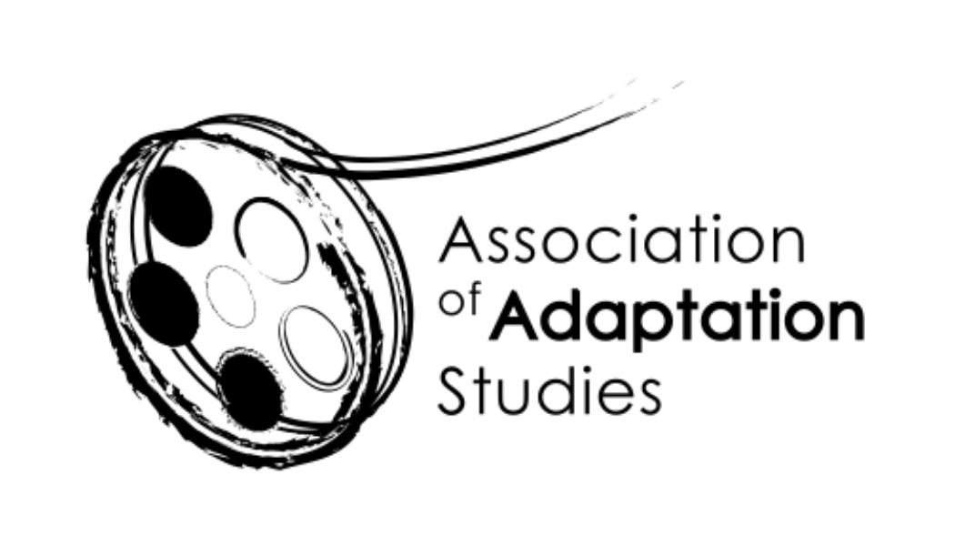
Association of Adaptation Studies
Registered Charity
1133677

AGM

Virtual meeting in association with the AAS Conference
hosted by Queen Margaret University, Edinburgh

08/06/2021

- To approve the minutes of the 2020 AGM (Kyle Meikle, Secretary)

The minutes were approved by those who attended last year.

- Chairs’ report
Membership (Julie Grossman and Jim Fleury)

Julie confirmed that we are in a very good place with membership. We have 100% enrolment from our presenters; everyone presenting at the conference is a member.

We have 122 members, up from 91 last year.

Thanks to Jeremy, Anna, and Jim for revising fee structure for dues. We have reduced the fee structure for concessionary memberships. 30GBP standard, 5GBP concession, 18GBP for those who would like to subscribe to the journal.

AAS website (Jim Fleury and Kyle Meikle)

A call for anyone to submit material to the website. Jim posted his email address in the chat. Kamilla solicited ideas for the site/newsletter.

AAS newsletters (Julie Grossman and Kamilla Elliott)

Julie added: if you’re not receiving the newsletters, please let us know. CFPs, announcements, features, etc. Send us information to include. Call for notes on this year’s conference. If you take notes on anything particularly interesting, please send in the next week or two. Kamilla: If people would like to edit a newsletter, please let us know.

- Treasurer’s report (Anna Blackwell)

Treasurer’s report: provisional numbers suggest that we’re in a good position. The
AAS account is at roughly 17,358.21GBP (exact bank figure pending). Offered a breakdown where folks were coming from (majority domestic, followed by US, Germany, etc).

- AAS YouTube channel (Eckart Voigts)

Eckart shared the content channel; videographic intro to Shakespeare and animated production; Kamilla’s welcome speech to AAS; intro to books on adaptation studies; playlists for (for instance) Palgrave series, Kamilla’s book launch, related videos. Eckart shared analytics: 117 views in the last 28 days. Eckart solicited more material. Kamilla solicited recorded lectures/excerpts/aiming for shorter videos. Eckart included contact info in the chat.

- AAS diversity initiatives (Joyce Goggin)

Joyce spoke about the question of diversity and about the diversity embedded into the AAS conference so far. Joyce is planning to do interviews with scholars who represent a more diverse perspective. She thanked the conference organizers.

- Links between AAS, LFA, MLA, NEMLA, SAMLA (Julie Grossman and Tom Leitch)--other links?

Tom presented a list of upcoming events of interest to adaptationists, including To Be Continued (adaptation/seriality roundtable in September), LFA’s Work & Play conference (in October), Social Networks, Social Distances at SAMLA (in November), Multilingual US at MLA (in January), a joint LFA/AAS in February, CARE at NEMLA in March.

- Student bursaries and graduate pre-conference workshops, AAS conference 2022 (Jeremy Strong and Monika Pietrzak-Franger)

Jeremy reported on two types of travel bursaries: postgraduate (EU/UK up to two at 250GBP and outside the EU/UK up to 500GBP), early career researcher (typically within three years of getting their PhD, in UK – lecturer scale rather than senior lecturer or higher – one EU/UK and one outside up to 500GBP). Jeremy stressed the importance of the award to foster scholarship, and stresses—along with Kamilla—the ease of the form. Kamilla: we may need to rethink these distinctions if and when conferences move outside the EU/UK.

Monika: Hoping to launch pre-conference workshop next year (around 22 June). Doctoral students and people working on their first book would be invited to speak about their ideas for roughly 15 minutes before getting feedback. Monika mentions fluctuations in interest this year and suggests making sure to acknowledge participants in the main conference program. Hopefully this will include a 50GBP bursary in the future. Anna to work on the logistics with Monika.

- Future AAS conferences (Kamilla Elliott)
University of Lisbon, Lisbon, Portugal, 23-24 June 2022
Other potential future locations: Sophia University, Tokyo, Japan; Oxford University, Oxford, UK; Vellore Institute of Technology, Chennai, India
Future conference set for University of Lisbon next year. John Williams has expressed serious interest in hosting a conference in Sophia University in Tokyo; Deborah Cartmell has offered to spearhead another conference at Oxford University in the UK (for either main or interrum conference). Julie reports on Akaitab Mukherjee’s interest on hosting a conference at Vellore Institute of Technology in Chennai, India. Kamilla wants to explore a hybrid conference that could be more accessible. Kamilla solicits more ideas for conference venues (doesn’t have to be a host university, e.g. Deborah hosting at BFI).

- AAS membership and conference participation (Julie Grossman)

Kamilla mentions a possible amendment to procedure so that membership would not be required for submitting but would be required for presenting.

- AAS Trustee elections June 2022 (Kamilla Elliott)

Election coming up next year. Kamilla stresses that all trustees will have to be willing to work. Change to procedure: Invites anyone who nominates themselves to provide a statement saying what they would be interested in doing.

- Any other business

Jeremy promotes PhD studentships at the University of West London for a September 2021 start. These include a £15,000 annual stipend for 3 years. These are available to UK students. Encourages those interested in adaptation to get in touch with him.

- Date of Next Meeting: 23 June 2022, University of Lisbon

