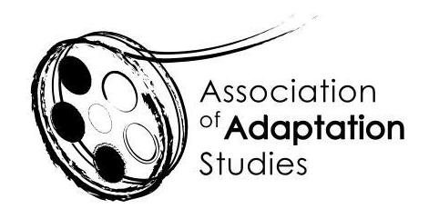

POSTGRADUATE TRAVEL BURSARY APPLICATION

The Association of Adaptation Studies 15th Annual Conference

University of Burgundy, Dijon, France | October 1-2, 2020

Up to three travel bursaries are available for postgraduate students delivering research papers at the 2019 conference: up to two for students based in the EU (£250 each) and one for students based outside of the EU (£500 each). We expect you to be proactive in applying for funding from your home institution, and other appropriate sources. Bursary applicants must be registered members of the AAS. To register please follow this link: http://www.adaptation.uk.com/join-the-association/

Applications should be sent to Professor Jeremy Strong (jeremy.strong@uwl.ac.uk)
Applications must be submitted no later than 30 April 2020.

Name
Email
Institution
Year of Study (MA/PhD)
Paper Title
Paper Abstract
(150 words)

Amount of funding provided by your institution
Amount applied for from other funding sources (list)
Please state why the travel bursary would be helpful to you (maximum 150-words)

