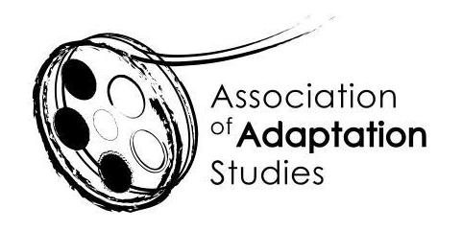

POSTGRADUATE TRAVEL BURSARY APPLICATION

The Association of Adaptation Studies 14th Annual Conference

Masaryk University, Brno, Czech Republic | September 19-20, 2019

Up to four travel bursaries are available for postgraduate students delivering research papers at the 2019 conference: up to two for students based in the EU (£250 each) and up to two for students based outside of the EU (£500 each). We expect you to be proactive in applying for funding from your home institution, and other appropriate sources. Bursary recipients must be registered members of the AAS. To register please follow this link: http://www.adaptation.uk.com/join-the-association/

European applications should be sent to Professor Jeremy Strong (jeremy.strong@uwl.ac.uk)
Non-European (long-haul) travel applications should be sent to Professor Barton Palmer (ppalmer@clemson.edu)
Applications must be submitted no later than Friday 15 April, 2019.

Name
Email
Institution
Year of Study (MA/PhD)
Paper Title
Paper Abstract
(150 words)

Amount of funding provided by your institution
Amount applied for from other funding sources (list)
Please state why the travel bursary would be helpful to you (maximum 150-words)

