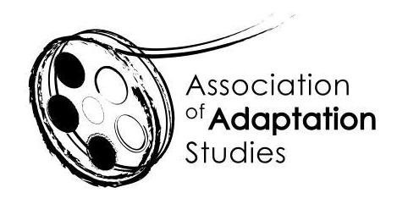

POSTGRADUATE TRAVEL BURSARY APPLICATION

The Association of Adaptation Studies 13th Annual Conference

University of Amsterdam | September 2018

Four travel bursaries are available for postgraduate students delivering research papers at the 2018 conference: two for students based in the EU (£250 each) and two for students based outside of the EU (£500 each). We expect you to be proactive in applying for funding from your home institution, and other appropriate sources. Bursary recipients must be registered members of the AAS. To register please follow this link: http://www.adaptation.uk.com/join-the-association/

Applications should be sent to Professor Kamilla Elliott (k.elliott@lancaster.ac.uk);
Applications must be submitted no later than Friday 30 June, 2018.

Name
Email
Institution
Bursary (EU or Non-EU)
Year of Study (MA/PhD)
Paper Title
Paper Abstract (150 words)

Amount of funding provided by your institution
Amount applied for from other funding sources (list)
Please state why the travel bursary would be helpful to you (maximum 150-words)

